# [DHTxx Sensors](https://learn.adafruit.com/dht/overview) [Basic temperature & humidity sensors](https://learn.adafruit.com/dht/overview)

[DHT temperature & humidity sensors](http://www.adafruit.com/category/35_66).

<https://learn.adafruit.com/dht>

**Overview**

This tutorial covers the low cost [DHT temperature & humidity sensors](http://www.adafruit.com/category/35_66). These sensors are very basic and slow, but are great for hobbyists who want to do some basic data logging. The DHT sensors are made of two parts, a capacitive humidity sensor and a [thermistor](http://learn.adafruit.com/thermistor). There is also a very basic chip inside that does some analog to digital conversion and spits out a digital signal with the temperature and humidity. The digital signal is fairly easy to read using any microcontroller.

[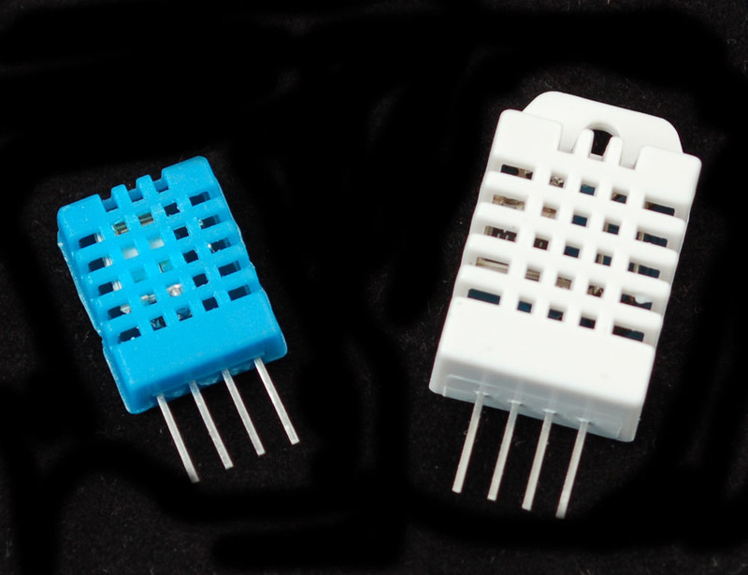](https://learn.adafruit.com/assets/576)

**DHT11 vs DHT22**

We have two versions of the DHT sensor, they look a bit similar and have the same pinout, but have different characteristics. Here are the specs:

[**DHT11**](http://www.adafruit.com/products/386)

* Ultra low cost
* 3 to 5V power and I/O
* 2.5mA max current use during conversion (while requesting data)
* Good for 20-80% humidity readings with 5% accuracy
* Good for 0-50°C temperature readings ±2°C accuracy
* No more than 1 Hz sampling rate (once every second)
* Body size 15.5mm x 12mm x 5.5mm
* 4 pins with 0.1" spacing

[**DHT22**](http://www.adafruit.com/products/385)

* Low cost
* 3 to 5V power and I/O
* 2.5mA max current use during conversion (while requesting data)
* Good for 0-100% humidity readings with 2-5% accuracy
* Good for -40 to 125°C temperature readings ±0.5°C accuracy
* No more than 0.5 Hz sampling rate (once every 2 seconds)
* Body size 15.1mm x 25mm x 7.7mm
* 4 pins with 0.1" spacing

As you can see, the [DHT22](http://www.adafruit.com/products/385) is a little more accurate and good over a slightly larger range. Both use a single digital pin and are 'sluggish' in that you can't query them more than once every second or two.

**Connecting-to-a-dhtxx-sensor**

Luckily it is trivial to connect to these sensors, they have fairly long 0.1"-pitch pins so you can plug them into any breadboard, perfboard or similar.

[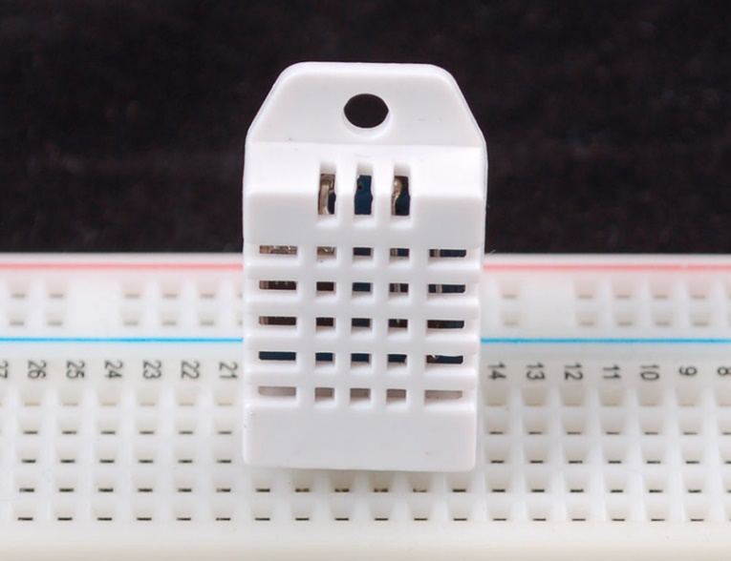](https://learn.adafruit.com/assets/577)

Likewise, it is fairly easy to connect up to the DHT sensors. They have four pins

* VCC (3 to 5V power)
* Data out
* Not connected
* Ground

Simply ignore pin 3, its not used. You will want to place a 10K resistor between VCC and the data pin, to act as a medium-strength pull up on the data line. The Arduino has built in pullups you can turn on but they're very weak, about 20-50K

This diagram shows how we will connect for the testing sketch. Connect data to pin 2, you can change it later to any pin.

[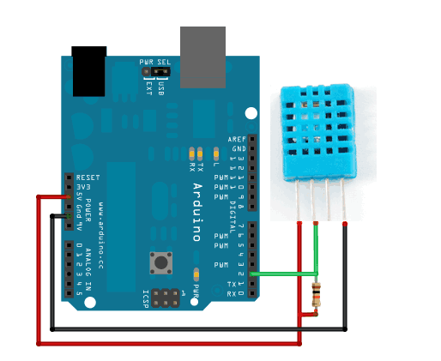](https://learn.adafruit.com/assets/578)

**Using a DHTxx Sensor**

To test the sketch, we'll use an Arduino. You can use any micrcontroller that can do microsecond timing, but since its a little tricky to code it up, we suggest verifying the wiring and sensor work with an Arduino to start.

[Begin by downloading the DHT library from our github repository.](http://learn.adafruit.com/dht/downloads) To download, click the **DOWNLOADS** button in the top right corner. Rename the uncompressed folder **DHT** and make sure that it contains the **dht.cpp** file and others. Then drag the **DHT** folder into the ***arduinosketchfolder*/libraries/** folder. You may have to create that libraries sub-folder if it doesnt exist. Restart the IDE

Now load up the **Examples->DHT->DHTtester** sketch

[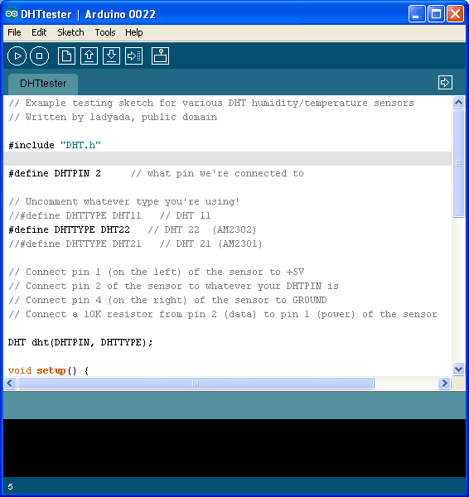](https://learn.adafruit.com/assets/579)

If you're using a **DHT11** sensor, comment out the line that sets the type: //#define DHTTYPE DHT22 // DHT 22 (AM2302)

//#define DHTTYPE DHT22 // DHT 22 (AM2302)

and uncomment the line that says:

#define DHTTYPE DHT11 // DHT 11

This will make the data appear correctly for the correct sensor. Upload the sketch!

[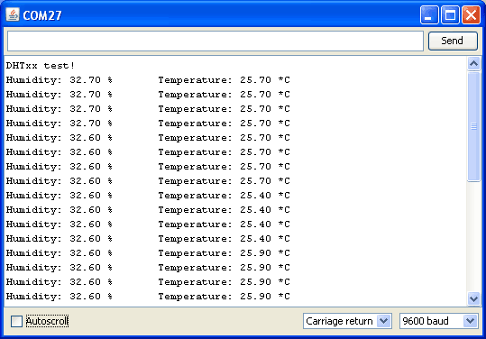](https://learn.adafruit.com/assets/580)

You should see the temperature and humidity. You can see changes by breathing onto the sensor (like you would to fog up a window) which should increase the humidity.

Ref:

<https://github.com/adafruit/DHT-sensor-library>

Heat index (热指数)是指人体在不同湿度的情况下对相同(高)温度感受指数。 比如同样是38度,空气中湿度越大,你感觉越热,相应的指数称为热指数

热指数是指高温时，当相对湿度增加后，人体真正感受到的温度会超过实际温度，也就是体感温度（Apparent temperature）。

<https://en.wikipedia.org/wiki/Heat_index>

The **heat index** (**HI**) or **humiture** or **humidex** (not to be confused with the [Canadian humidex](https://en.wikipedia.org/wiki/Humidex)) is an index that combines [air](https://en.wikipedia.org/wiki/Air) [temperature](https://en.wikipedia.org/wiki/Temperature) and [relative humidity](https://en.wikipedia.org/wiki/Relative_humidity) in an attempt to determine the human-perceived equivalent temperature—how hot it would feel if the humidity were some other value. The result is also known as the "felt air temperature" or "[apparent temperature](https://en.wikipedia.org/wiki/Apparent_temperature)". For example, when the temperature is 32 °C (90 °F) with very high humidity, the heat index can be about 41 °C (106 °F).

<https://en.wikipedia.org/wiki/Dew_point>

美国国家气象中心根据Steadman（1979）的研究，依据温度、相对湿度等相关气象因子，导出热指数公式：

HI = -42.40+ (2.04901523 * [TEMP])+ (10.14333127 * [HUMIDITY])-(.22475541 * [TEMP] * [HUMIDITY])-(.00683783 * ( [TEMP]^2 ))-(.05481717 * ( [HUMIDITY]^2 ))+(.00122874 * ( [TEMP] ^2) *[HUMIDITY]) +(.00085282 * [TEMP] * ( [HUMIDITY]^2 ))-(.00000199* ( [TEMP] ^2 ) * ( [HUMIDITY] ^2))

**Dew point** is a measure of atmospheric moisture. It is the temperature to which air must be cooled to reach saturation (assuming air pressure and moisture content are constant). A higher dew point indicates more moisture present in the air. It is sometimes referred to as dew point temperature, and sometimes written as one word (dewpoint).[[1]](https://en.wikipedia.org/wiki/Dew_point#cite_note-1) Frost point is the dew point when temperatures are below freezing.[[2]](https://en.wikipedia.org/wiki/Dew_point#cite_note-2)

In simpler terms: the dew point, or frost point, is the temperature at which dew or frost will form should the air temperature fall sufficiently. Other things being equal, as the temperature falls, the relative humidity rises, reaching 100% at the dew point, at least at ground level. Dew point temperature is never greater than the air temperature, since the relative humidity cannot exceed 100%.[[3]](https://en.wikipedia.org/wiki/Dew_point#cite_note-3)

露点（Dew point），又称露点温度（Dew point temperature），在气象学中是指在固定气压之下，空气中所含的[气态](http://baike.baidu.com/view/170430.htm)[水](http://baike.baidu.com/view/2630.htm)达到饱和而[凝结](http://baike.baidu.com/view/629882.htm)成液态水所需要降至的温度。在这温度时，凝结的水飘浮在空中称为雾、而沾在固体表面上时则称为露，因而得名露点。